Indian Institute of Technology, Kharagpur
Centre for Educational Technology

Mid Semester Examination 2019

Subject: INTRODUCTION TO DIGITAL SPEECH PROCESSING Code: ET60007

Time: 2:00 Hours PART-A:-10*2=20; PART-B:-5*6=30 Full Marks =50

Answer all the questions of PART-A and PART-B
(Please enclosed the Annexure-1 along with the answer script)
PART-A
- Two source of speech signal producing a vowel /e/. The overall intensity of one source is 20dB and other is 21dB. If a human being perceives the two sounds as same intensity sounds describes the reason.

- Acoustic intensity of an audio system is 5W/m². Represent it in dB and find out the Loudness (L) in Sones.

- Write the speech perceptual parameters name.
- If figure-1 represent the frequency response of uniform tube in no loss condition. Draw the frequency response of the uniform tube if effect of wall vibration is considered

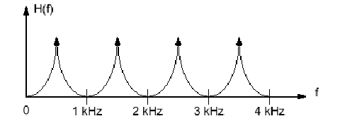
Figure-1
- Time varying glottal resistance and inductance-both functions of glottal opening A_{G}(t). If the glottis is completely closed what will be the value of glottal impedance and volume velocity

- First formant frequency of a steady state vowel is F₁=250Hz. Consider that the vowel is produced using a single lossless acoustic tube. How long is the impulse response of the tube? Where the speed of sound c=350m/s.
- Figure-2 represents the production of a consonant write the manner and place of articulation of the consonant
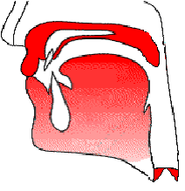
Figure-2
- Write the place of articulation of the following phonemes?
/b^{h}/, /t/, /k/, /ɖ/
- 2 sec. speech segment is encoded using LPC coefficient and the LPC coefficient are extracted for each frame with a frame rate 100 frame/s. Calculate numbers of LPC coefficient frames can be extract from the above speech signal? Where sampling frequency Fs=16 kHz
- An audio signal is recorded using the following format. To store 200ms signal in PCM WAV format how much memory is required?
F_{S} = 44.1 KHz, encoded with 16 bit and recoded in MONO

PART-B
- A speech production system is model using Uniform Tube Modeling and it produces a voice sound. Figure -3 shows the spectrum of the above voice sound along with the formant frequency and formant bandwidth with sampling frequency F_{S} = 10 kHz. Derive the transfer function of the above Uniform Tube Model. General equation of the Uniform Tube Model is given in equation (1). Draw the digital implementation diagram of the model.
(1)
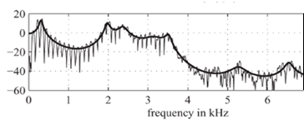
F1= 2200 Hz
BW=65 Hz

F1=740 Hz
BW=68 Hz

F1=350 Hz
BW=98 Hz

F1=3100 Hz
BW= 55 Hz

F1= 5000 Hz
BW=112 Hz

F1=4200 Hz
BW=140 Hz

Figure -3
- A causal LTI system has system function is given in equation-1. Equation 2 represents the expression of prediction error filter A(z). Lattice Formulations of Linear Prediction as given in equation 3(a) and 3(b)
Where e[m] represents the forward prediction error, b[m] represents the backward prediction error and k_{i} is the PARCOR coefficient

3(b)

If the signal s[n] = {1,-2, 2} applied in the design error filter A(z) (as in question no. 2) where p=3, calculate the value of the forward prediction error at the output of the 2nd lattice.
- A speech signal is sampled at 16 KHz, 16 bit; determine the required order of the LPC analysis. If each of the LPC coefficients is encoded with 2 byte, Gain in 2 byte. Voiced Unvoiced and F₀ information is encoded using 2 byte. Calculate the compression ratio if frame rate is 100 frame /sec.

- If the order of the LPC analysis is 3 and LPC coefficients are {α₁, α₂, α₃} compute the model gain for a signal x[n] = {1, 2, 1,-1,2}

- A voiced based speed dialing system of a mobile phone is design for the following words. Figure-4(I) to (VI) in Annexure-1 shows spectrograms of one version of each of the words. Using your knowledge of acoustic phonetics, determine which spectrogram corresponds to which word.

(I) Home, (II) DIAL, (III) office, (IV) doctor, (V) School, (VI) Disconnect

Annexure-1

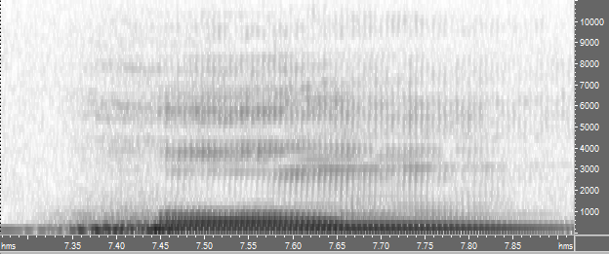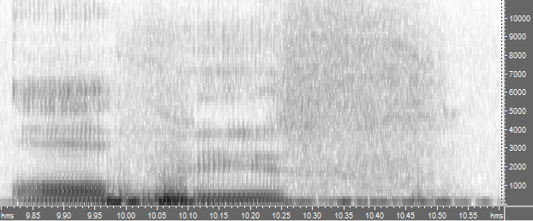

(I) ……………………… (II) ……………………………..

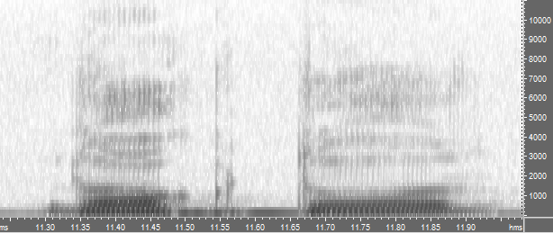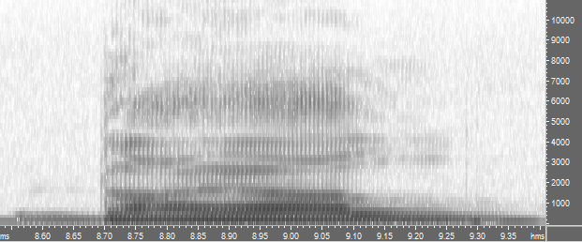

(III)………………………………….. (IV) …………………………………….

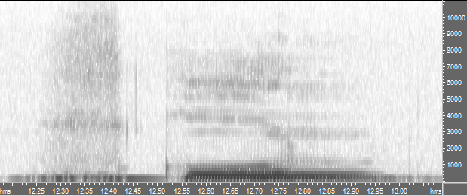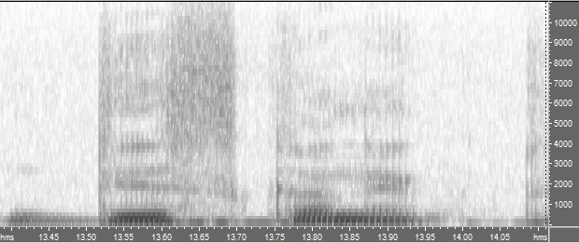

(V)……………………………… (VI) ..…………………….

